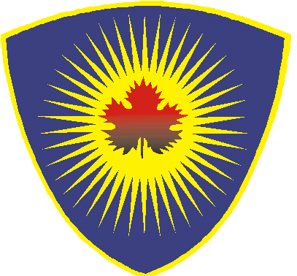
Anëtarët e Kuvendit të Komunës
Suharekë
1. Shefket KOLGECI 044-187-007
2. Selman KOLGECI 049-502-555
3. Flamur BYTYÇI 045-888-881
4. Urim SUKA 044-401-802
5. Kushtrim KUQI 044-692-424
6. Elmaze BYTYÇI 044-337-837
7. Bulëza KUÇI 049-860-830
8. Doruntina ZENELAJ 049-837-514

1. Bexhet KUÇI 045-315-388
2. Reshat SELIMAJ 044-338-265
3. Lirim QATANI 044-717-966
4. Aziz BYTYÇI 049-885-335
5. Sanie KUQI 049-110-619
6. Mimoza BAJRAKTARI 049-268-355 044-460-939
7. Afërdita MORINA 049-626-608
8. Fidajie KUKAJ 045-916-915
1. Laureta TAFAJ 049-244-285

3. Qendrim ELSHANI 044-404-189

4. Festë KABASHI 049-597-054

AAK
VV
NISMA
2. Mevlude KABASHI 045-625-121
3. Bajram BASHA 044-276-737
4. Sheqerije ZYRAPI 049-612-049
11. Xhevxhet GASHI 049-232-543
10. Diton MALIQAJ 049-921-921
1. Jeton RRAKAQI 044-150-516
PDK
Jehona RRAFSHI 049-870-926
Iniciativa Qytetare
9. Saranda BAJRAKTARI 049-527-723

9. Alban BERISHA 049-662-554
12. Edon SADIKAJ 049-870-963
2. Liridon FANDAJ 049-154-365
Herolind LIMAJ 049-431-068

 | REPUBLIKA E KOSOVËS  REPUBLIKA KOSOVA-REPUBLIC OF KOSOVA  KOMUNA E SUHAREKËS  OPSTINE SUVA REKA-THE MUNICIPALITY OF SUHAREKA  ____________________________________________________  _____________

